1. Find out the network address of the following IP addresses

|  |  |
| --- | --- |
| 188.10.18.2/16 |  |
| 10.10.48.80/24 |  |
| 192.149.24.191/24 |  |
| 150.203.23.19/16 |  |

1. What class of network do the following IP addresses correspond to?

|  |  |
| --- | --- |
| 10.250.1.1 |  |
| 150.10.15.0 |  |
| 192.14.2.0 |  |
| 148.17.9.1 |  |
| 193.42.1.1 |  |
| 126.8.156.0 |  |
| 220.200.23.1 |  |
| 230.230.45.58 |  |

1. Fill in the missing data in the following table.

|  |  |  |  |  |
| --- | --- | --- | --- | --- |
| IP address | Network address/ Network mask | Broadcast address | Gateway address | IP address range |
| 192.168.240.120 |  | 192.168.240.255 |  |  |
| 172.6.12.34 |  |  | 172.16.0.1 |  |
| 10.1.1.1 |  |  |  | 10.0.0.2/10.255.255.254 |

1. Let's imagine that we must configure a network with 50 computers using private IPs: What kind of IP address do I need? - Choose a network address among the possible ones.

What range of IP addresses will we use? What netmask does that IP address have?

What range of IP addresses can I assign to hosts? What IP will I assign to the gateway?

Fill in the values in the following image selecting for the 4 PCs some of the possible addresses available.

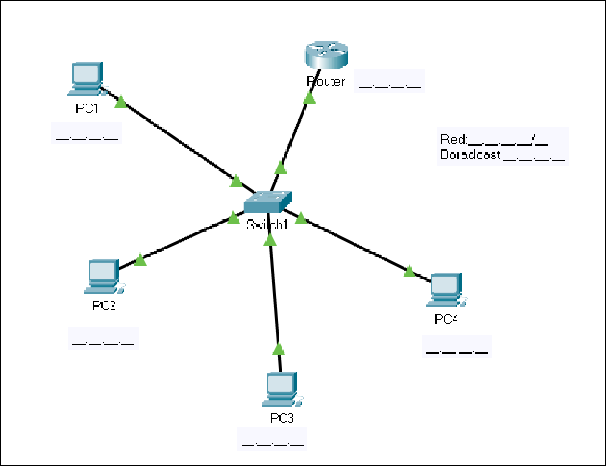

1. Subnetting. Suppose we need to configure IP addressing

A company has a class C network and needs to create 2 subnets with the capacity to connect at least 40 computers in each of them. Write the network identifier and the subnet identifier knowing that IPv4 addresses are used.